Beginner Linux Challenges

Task 7
- $ nano my_bio.md
figure 1
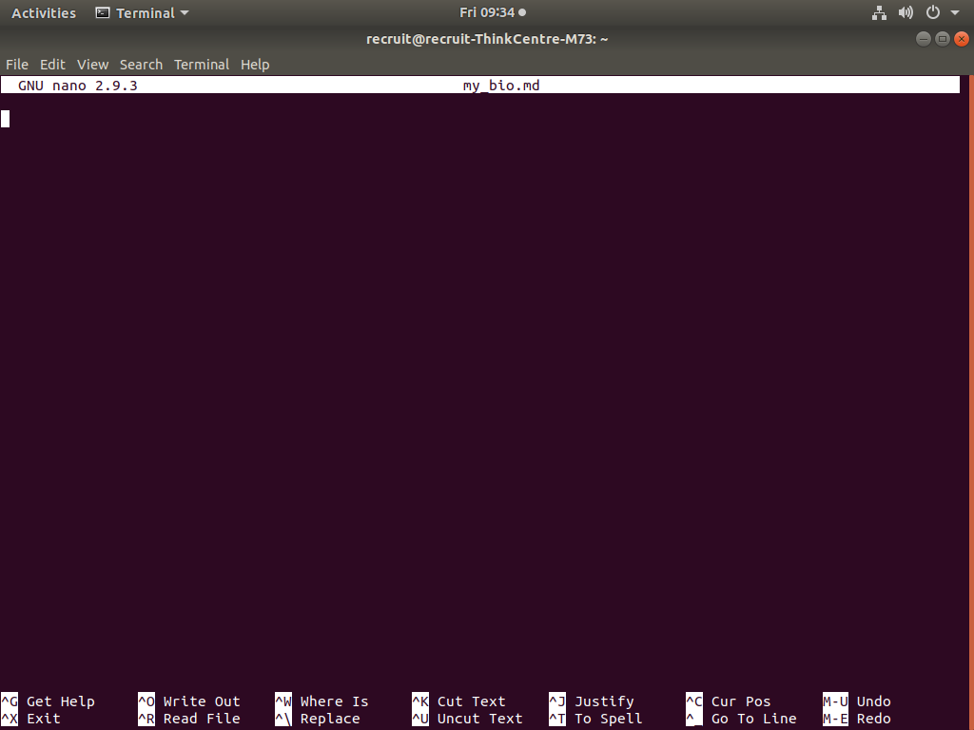
- Pressing “Ctrl + O” saves the document and “Ctrl + X” exits nano
- Please see figure 2
figure 2
